
CnG Golden Market Affordability: Mockup Testing/ Research Report
June 2022 | Kelly Peterson Nithin Alexander Isabella Anastassoff Yunyu Zhou

| TLDR:
- Cx may not realize the fee tests until they checkout due to ad fatigue
- Cx understand and like flat fees; they feel 9.99 is too high
- Cx are confused by the inverse fees mockup and the value point is not clear
- Cx did not pick up on inflation in the cart shown, they like seeing $0 service and delivery fees

| Goals of this Research:
- Identify any questions or areas of confusion Cx have on the affordability experiments set to run this month
- Get a pulse on discoverability and if the offerings stand out to Cx on grocery homepage and store pages
- Collect high level Cx feedback on the offerings

| Link:
https://www.figma.com/proto/XdngzgfP1iTGaZ3edvwmFC/22Q2-Golden-Market-Affordability?page-id=332%3A87820&node-id=332%3A88347&viewport=1058%2C-157%2C0.14&scaling=scale-down&starting-point-node-id=332%3A116165&show-proto-sidebar=1

| Sample details:
- Total of N=8 Cx who do not currently have DashPass
  - N=4 have purchased grocery before
  - N=4 have not purchased grocery but were aware that DoorDash offered groceries
- Cx completed 20 min conversation where they were shown 2 mock ups to react to

| Insights:
Discovery:
- Cx experienced “ad fatigue” and ignored the banner on the grocery homepage assuming it was a “typical DoorDash promotion”
  - The only Cx that did not were those who said they open several apps to compare promotions before shopping
- 2 out of 8 Cx noticed the change in fees on the store tags on the grocery page
- All Cx felt it was super clear once they were in the chart
- All thought that offering was a short term promotion, not a new standard for grocery

Flat fees:
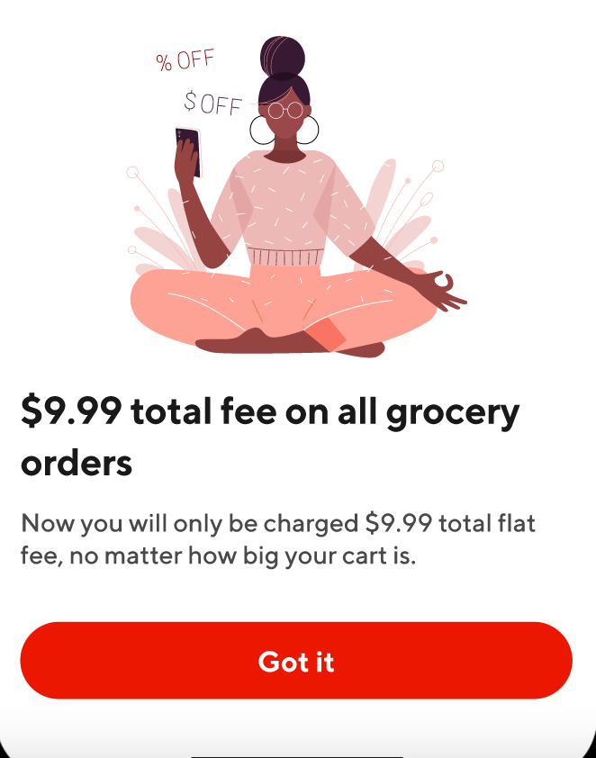
- The idea of a flat fee is clear and popular, but $9.99 is viewed as too high
  - Some Cx said 5.99 or 6.99 would make them more comfortable
  - One respondent said that 9.99 only made sense if you had at least 5 items in your cart, or it was 10lbs or two shopping bags worth of food
- Most Cx assumed tax was included in fees
  - All knew that tip would still be required
- 2 Cx questioned the items themselves and thought they were inflated (chicken & salmon)
  - Most Cx shown flat fees said that they did not think it was worth it for the cart example provided
- Some Cx indicated that they would rather see the 9.99 split across two fees, however, if it was a smaller amount it would be find to keep as one fee

Inverse fees:
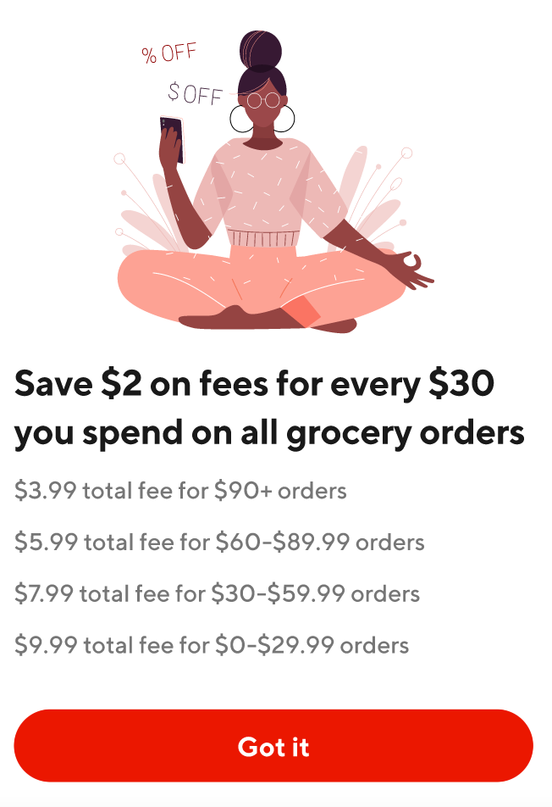
- All Cx shown this mock up were confused when reading it, some of the areas of confusion were
  - The banner did not provide the starting part for fees so it didn’t make sense
  - They thought it was $2 off their total at checkout
  - They thought $2 was off the example fee in the pop up screen (e.g. under $30 would be $7.99 because it was originally $9.99 in fees)
  - They felt it was hard to read the examples in the order they were shown (highest subtotal to lowest subtotal felt backwards)
  - 2 respondents were probed on the number of examples shown, both felt that 2 would make more sense
- In general folks felt like the focus of $2 in savings wasn’t worth the price difference that we were asking of them
  - 1 Cx said that she would rather not see the example that did not have the discount
- Some shoppers indicate they they shop for groceries sporadically so this would have a negative effect on their shopping experience

Inflation, no Fees:
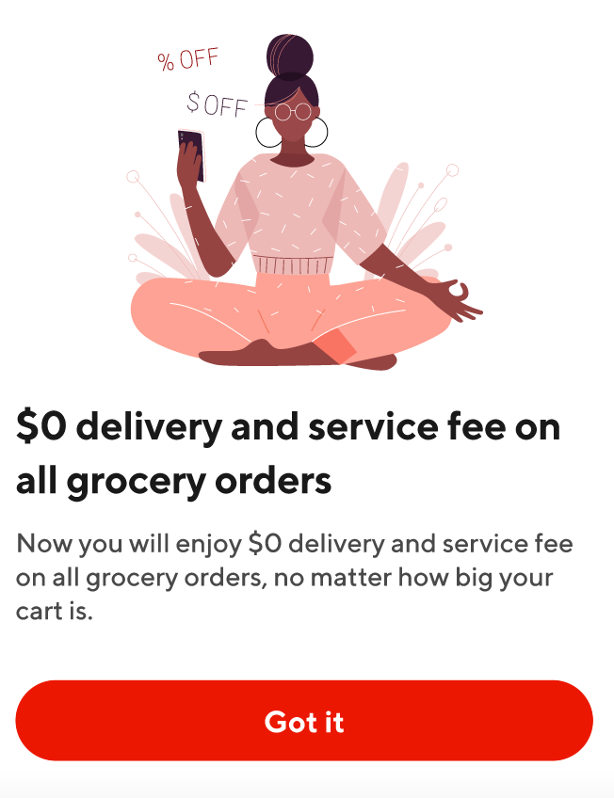
- None of the respondents interviewed picked up on inflation in the example checkout cart
- All Cx shown this mockup loved seeing $0 total fees, they said that they were likely to tip higher than they normally would because of this
- They felt the total price felt right at the end of the day
Important caveats for Inflation
- Cx did not shop for the items in their example cart and were not shown their preferred store/brand
- There was no text anywhere explaining that prices were inflated

| Recommendations:

- Explore ability to reduce flat fees or consider testing “flat fees starting at XX”
- Consider repositioning the inverse fees test as “savings identified” rather than $2 as Cx did not feel strongly about $2
  - Only show 2 examples for inverse fees test on the popup page
  - Use strikethrough and bold to make it super clear what the discounts will be on the popup page
- Additional testing recommended of inflation with language explaining that there is inflation to get Cx feedback (can be done async with experiment)
- Continue Cx feedback loop during and post experiments

